**Configuration management with puppet:**

Configuration management:

What is configuration management and why do we need configuration management?

The system administrators usually perform repetitive tasks such as Installing servers, configuring those servers, and so on … They can automate these tasks writing scripts but it is a very hectic job when you’re working on a very large infrastructure.

There are a couple of issues without automation tool:  
1. having to configure a large number of servers together.

2. Scaling new servers manually without any configuration management tool.

3. Dependency of environment.(there is always a development and deployment environment mismatch. Which is going halt the work from time to time)  
  
So to solve these problems configuration management was introduced to workplaces.

configuration management is the practice of handling changes systematically .

So that a system maintains its integrity over time.  
  
CM ensures that the current design and build state of the system is known good and trusted and doesn’t rely on the knowledge of the development team.

It allows access to the architecture historical record of system state for project management and audit puposes.

So with the CM you overcome following challenges : (Major categories of devops life cycle that can use automation)

1. Figuring out which components to change and when the requirement changes.
2. You also redoing an implementation because the requirements have changed since the last implementation.
3. You can also do reverting to previous version of the component if you have replaced it with new but flawed version.
4. Replacing the wrong component just in case you couldn’t accurately determine which components needed replacing.

Example: Automated scenario:

Dev passes updates to operations and now scaling is not an issue. Adding 200 servers as said by the manager not really a problem with the help of CM.   
operations can easily scale, deploy and configure as many servers as his manager wants.

The best example for this is NEWYORK STOCK EXCHANGE

A s/w glitch had prevented the NTSC from trading stocks for almost an hour and half. This led to millions of dollars loss.

A new s/w installation was actually the cause of this problem.The s/w was installed on 8/20 of the NYSC trading terminals. However being tested out the night before it failed to operate properly in their 8 terminals. So there was a need to switch back to their old s/w. As a result of proper configuration management NYSC recovered from that situation in 90 mins which is pretty fast for a scenario like these. Had the problem continued longer the consequences would happen far more severe.   
  
Now I hope you understand the importance of CM which is considered the backbone of devops. It allows more frequent s/w releases in the safest and most reliable way possible.   
  
What is configuration management? (def)  
CM is all about bringing in consistency in the infrastructure. This is done by ensuring that the current design system, state and environment is known. Trusted and agreed upon by everyone. CM also helps record all the changes in the system.

CM tools provide an easy approach to manage and configure server. It enables users to manage and configure the entire infrastructure and its environment. It makes writing individual scripts for server time and time again just to get little things done obsolete.

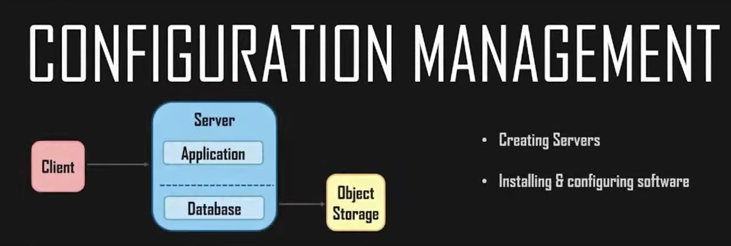

And it does so in one concept particular.   
  
Infrastructure as code (IaC) :   
  
Infrastructure as code enables IT operations by provisioning of code, rather than manually handling each phase of different environments. It bridges the environment differences system admins encountered every time they had to either deploy new code or set up new servers.   
  
Here is the shell script and CM script:

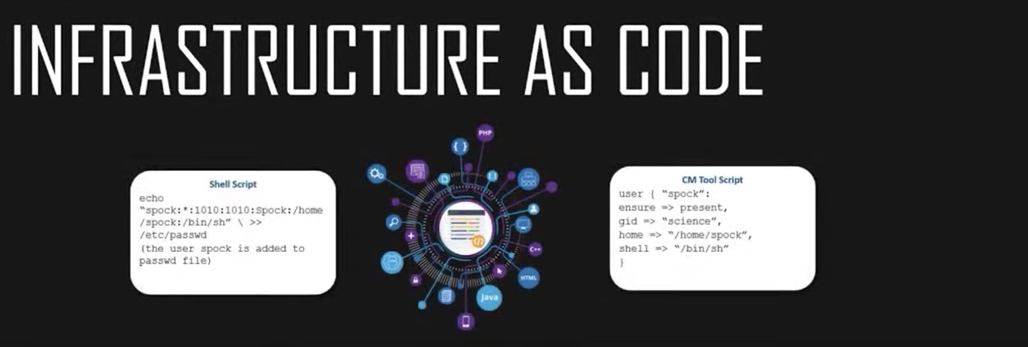

Both the scripts are adding a user to the host, but the CM tool script is easy to understand and write as you can see its almost pure English. The shell script is harder to understand and you should you’ll have to learn to write shell scripts of your own in the first place.   
  
Iac has its own advantages, For Ex: provisioning servers using IaC is way easier than writing shell scripts. Shell scripts will require workflow definitions as you just saw whereas the CM tool scripts has predefined workflows. So that basically makes the CM tool scripts easy to understand and write, while eliminating the requirement to learn and how to write shell scripts separately.   
  
  
Now there are very popular CM tools such as Salt Stack, Ansible, CFEngine, and Chef, Puppet.   
  
Lets see Puppet:

What is Puppet ?   
Puppet is CM tool that helps orchestrate, provision, deploy and configure the entire infrastructure of an organization. Puppet enables users to concentrate more on making delivery faster and more reliable rather than continually fixing mistakes.

It defines distinct configurations for each host and continually checks and confirms whether the required configuration is in place and is not altered and if altered puppet immediately reverts back to the required configuration on the host. It also helps in dynamic scaling up and scaling down of machines while providing control over all your configured machine. So, a centralized or a master server or a repo-based change gets propagated to all automatically. SO, puppet uses a master-slave architecture. The diagram in front of you depicts what happens.

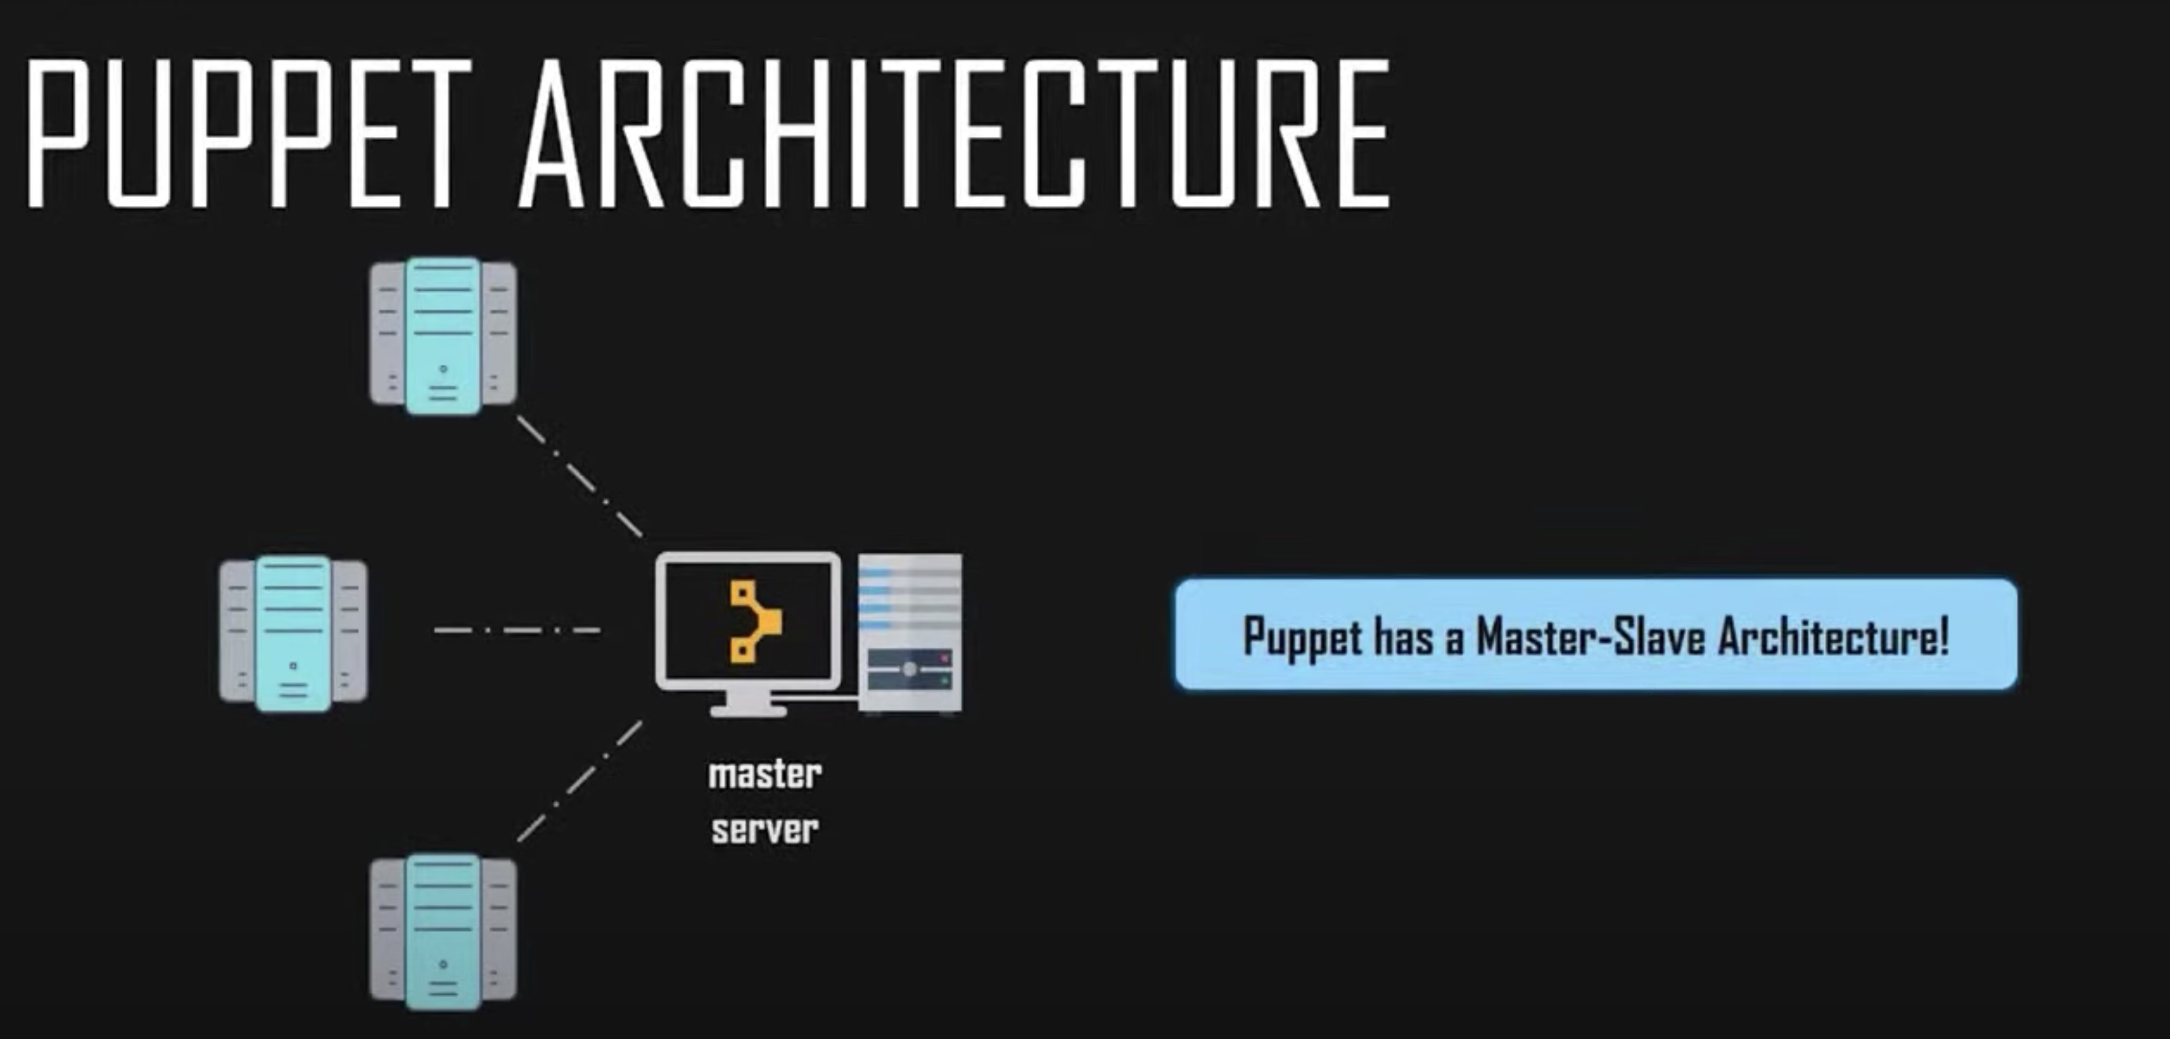

So let me break it for you a little bit, there is something known as a puppet agent which sends facts to the puppet master. The facts are basically your key-value data pair that represents some aspect of the slave state like its IP address, its uptime OS, or whether it’s a VM or not.

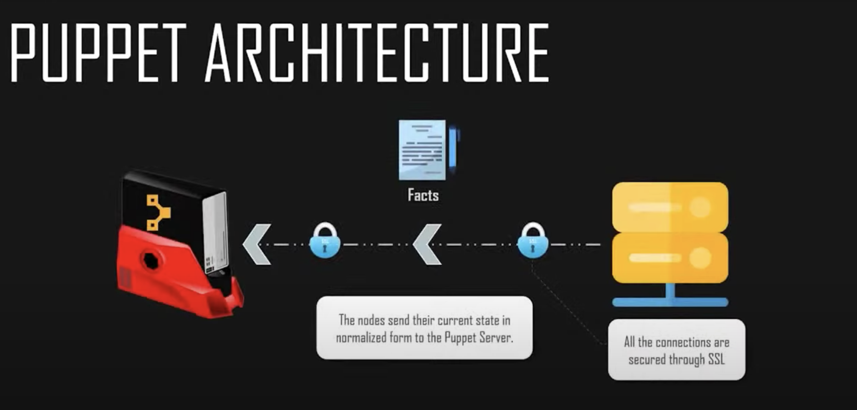

The puppet master uses these facts to compile a catalog that defines how a slave should be configured. The catalog is a document that describes a desired state for each source that the puppet master manages on a slave.

Finally the puppet slave reports back to the master indicating that the configuration is complete which Is visible in the dashboard.  
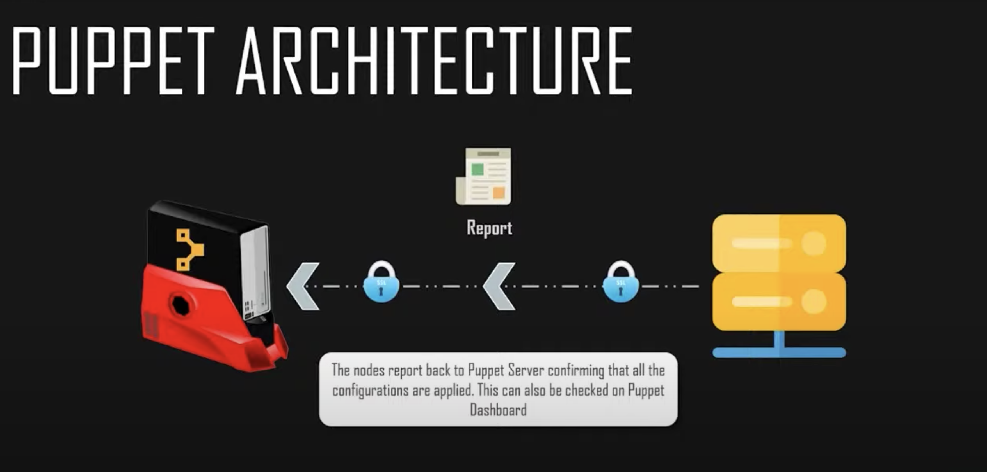

The puppet master and puppet slave communicate with each other through a secured encrypted channel with the help of SSL. The puppet slave asks for the puppet master certificate. After receiving the puppet master certificate, the master requests for the slave certificate, once master has signed slave certificate the slave requests for configuration or data and finally the puppet master sends the configuration to the puppet slave and that is how this architecture works.

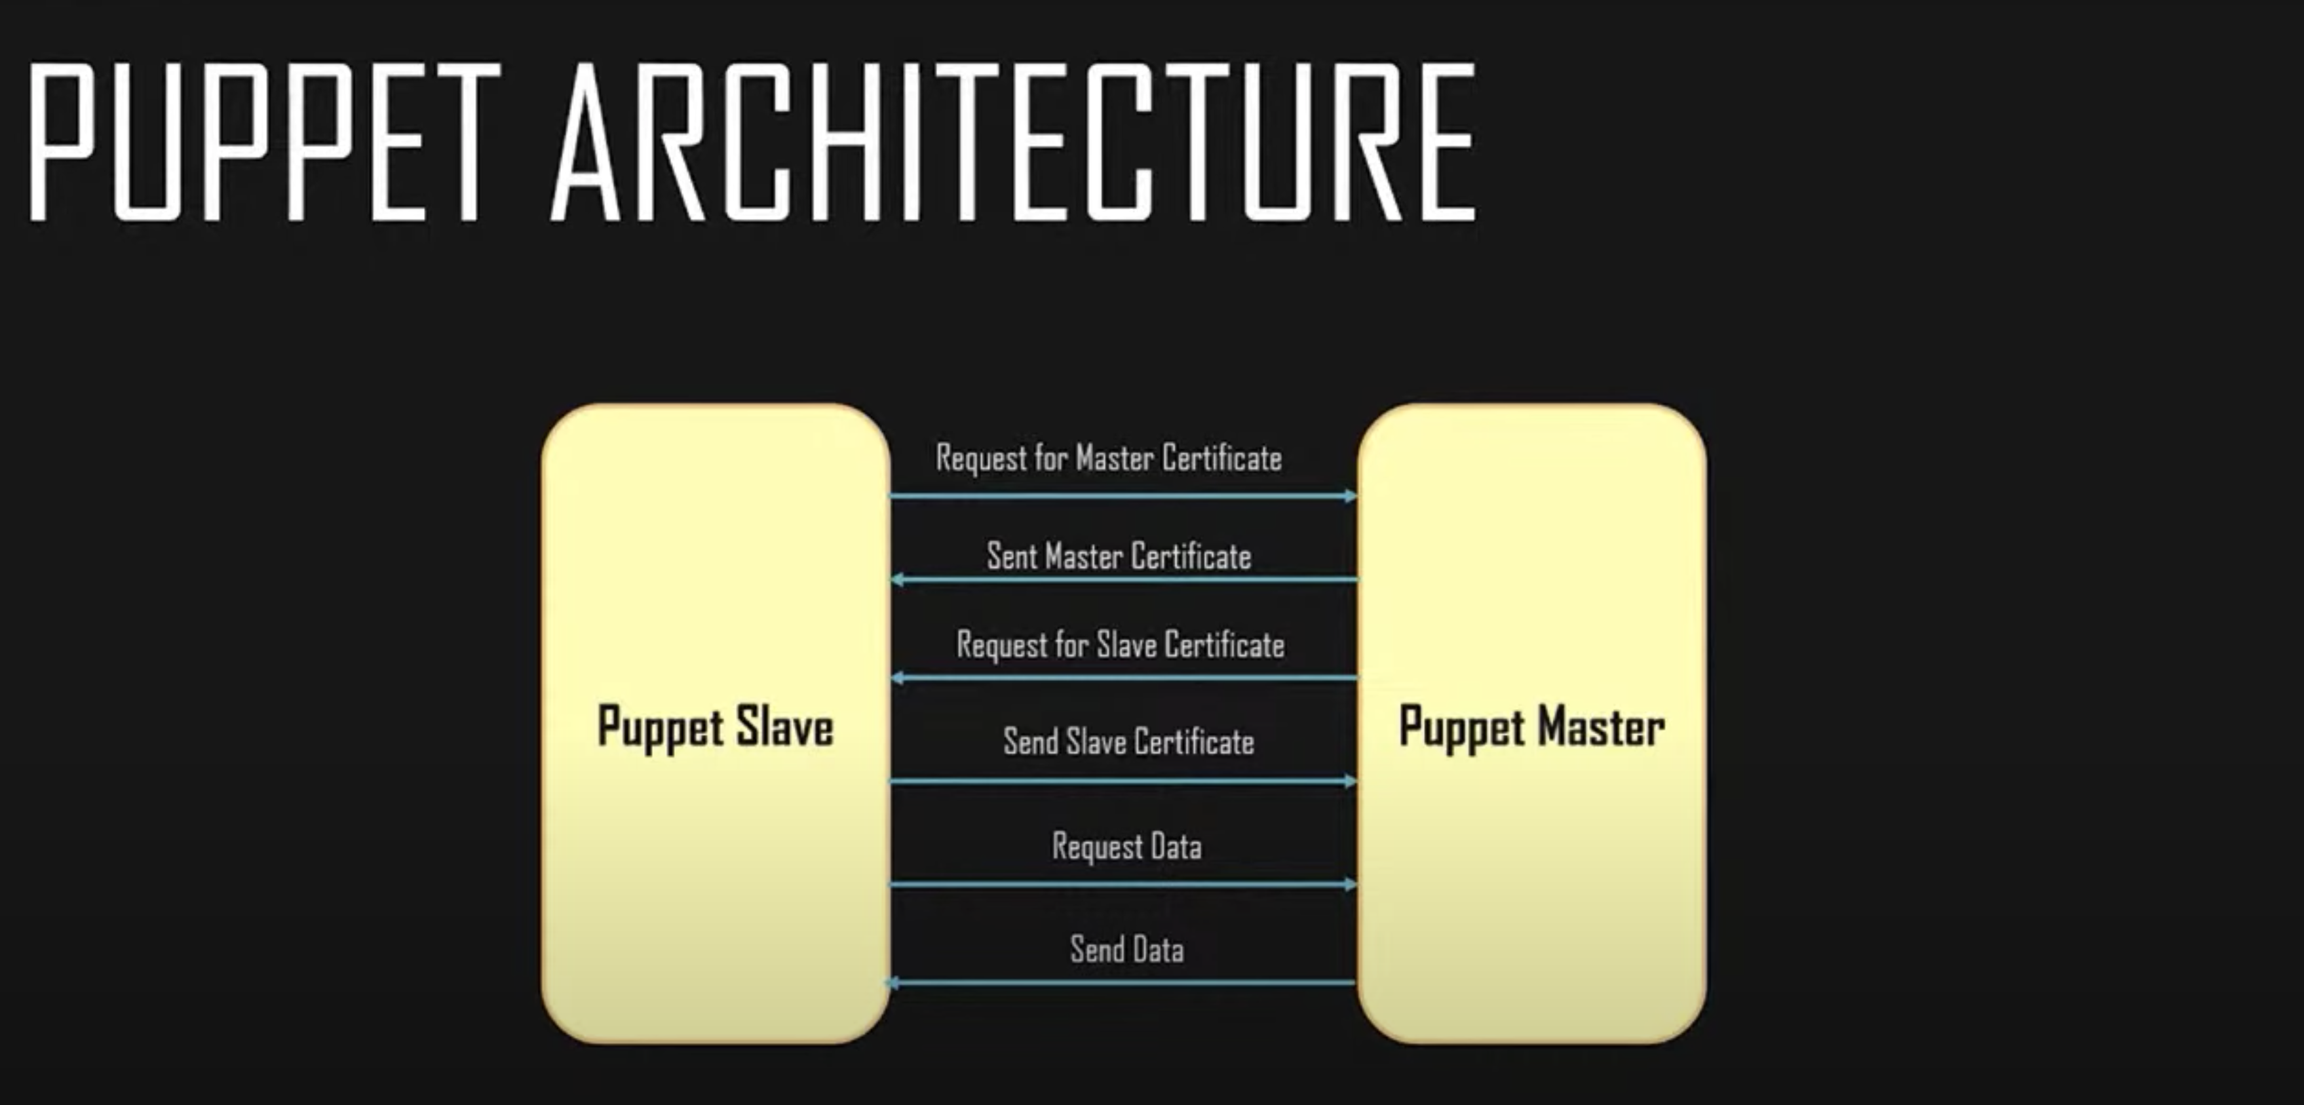

Let us look at few imp. Puppet components :

Puppet components:

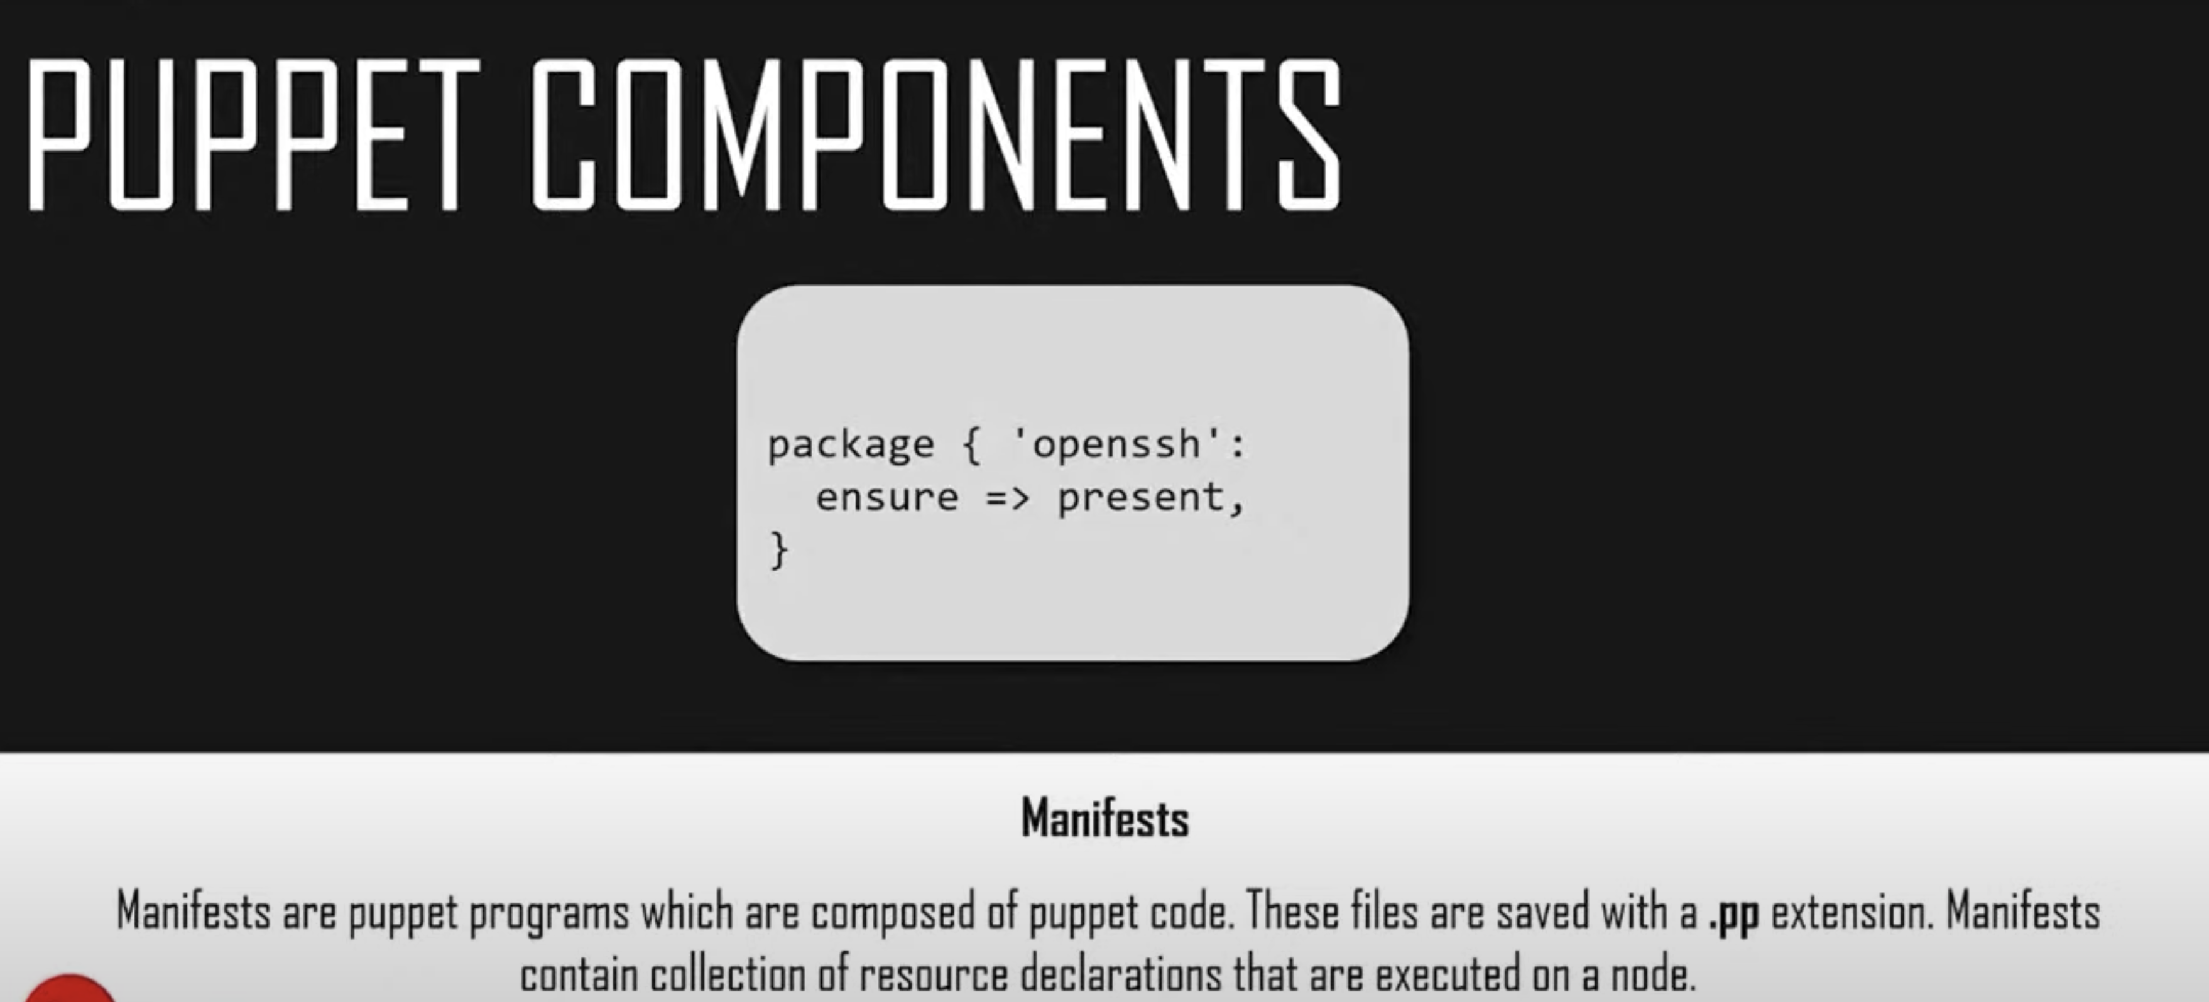

Manifests:

Each slave has got its configuration details in puppet master written in the native puppet language. These details are written in the language which puppet can understand and these are termed as manifests. They composed of puppet code and their file names using the. pp extension, they are basically like programs of puppet. for example, you can write a manifest in puppet master that creates a file and installs apache server on all puppet slaves that connected to the puppet master.

Module:   
  
  
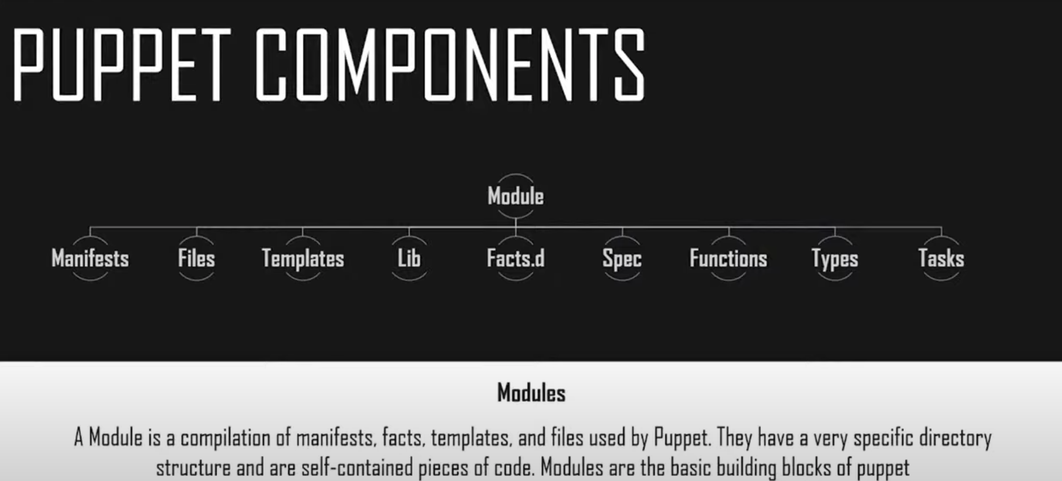

A puppet module is the collection of manifests and data such as facts, files, templates etc. And they have a specific directory structure. Modules are used for organizing puppet code bcoz they allow you to split your code into multiple manifests. Hence, they also known as self-contained bundles of code and data.

Resource:

Resources are the fundamental unit for the modeling system configurations. Each resource describes some aspect of a system, like a specific service or a package.

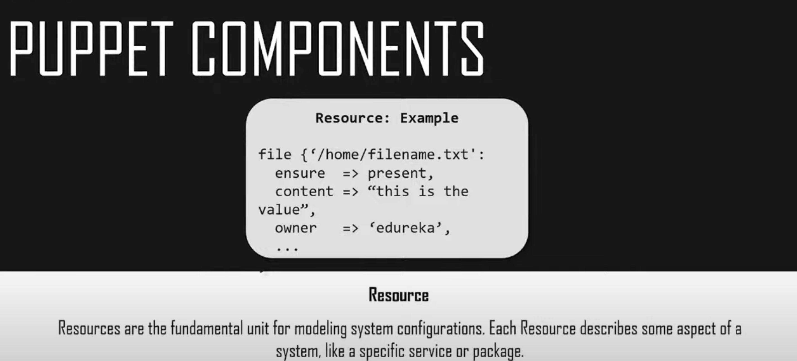

Factor:

Factor gathers a basic information(facts) about puppet slave such as hardware details, network settings, OS type, version, Ip addresses, Mac addresses, SSH keys etc. These facts are then made available in puppet master manifests as variables.

Mcollective:

It is a framework that allows several jobs to be executed in parallel on multiple slaves. It performs various functions such as interacting with clusters of slaves whether in small groups or in large deployments using a broadcast patter dime to distribute requests where all slaves receive all requests at the same time. Requests have filters attached and only slaves matching the filter can act upon the request. You can also use simple command line tools to call the remote slaves and write custom reports about your infrastructure using the Mcollective.

Catalogs:   
  
A catalog describes the desired state of each managed resource on a slave. It is a compilation of all the resources that the puppet master applies to a given slave, as well as the relationships between resources.

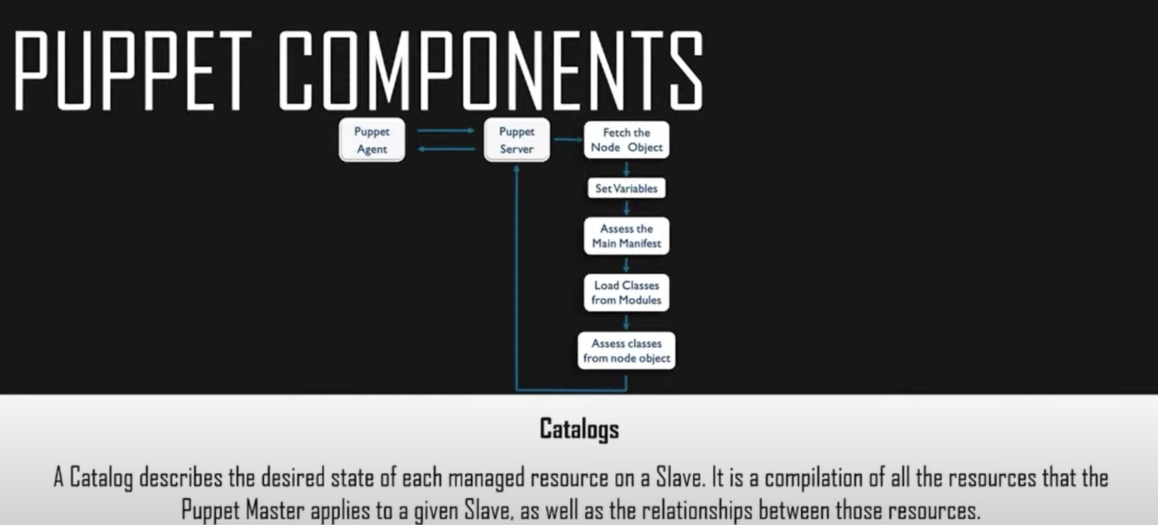

Now catalogs are compiled by a puppet master from manifests and slave provided data which includes facts, certificates, and environments want us provided. As well as an optional external data such as an external slave classifier exporter resources and functions. The master then serves the compile catalog to the slave when requested.

WHY PUPPET?   
  
If you’re a poker enthusiast or a card enthusiast or you have ever played online games then you must head about something called Zynga – the worlds largest social game developer. Its infrastructure uses thousands of servers, public cloud and private DC. Early on they were using manual processes including kick starters and post installs to get 100s of servers online. During the process they faced a number of different problems.

1. Scalability and consistency. (Lack of scalability)

The platform was experiencing phenomenal growth and its infrastructure needed to keep pace with the industry.

1. Need for portable infrastructure.
2. Lack of flexibility
3. Need for infrastructure insights

So they got puppet into picture.

1.speed of recovery

2.Speed of deployment

3.Consistency of servers.

4. collaboration

Puppet handson:

Go to AWS -> ubuntu server 18.04LTS(HMV) SSD VOLUME TYPE

T2 micro

Number of instances we- 2 master and slave(agent)

Configure security group :

ADD RULE -> ALL TCP

You can go ahead with this or you can use cutom TCP for agent.

Select ANYWHERE -> review and launch  
rename instances to master and slave.

Now as both the instances are running . lets start with master.

Let connect to master and start by installing NYP date packages to sync all your date and time on your servers.

sudo apt update

sudo apt install -y ntp ntpdate

we should take care that all of the above commands will run as root.

sudo ntpdate -u 0.ubuntu.pool.ntp.org

now we have installed ntp date packages and and synced our data time on our master.

Next we are going to setup hosts file on our machines and remember to run all these 3 commands on both of your machines.

Now on our masters you gonna edit the host file and add the IP address of the master itself in the hosts file and name it puppet.

sudo nano /etc/hosts

<IP-ADDRESS of master> puppet

In the agent we need to again edit hosts file . add the master and also add the puppet agent.

sudo nano /etc/hosts

<IP-ADDRESS of master> puppet

< IP-ADDRESS of slave > puppet-agent

Next step is we gonna add puppert repos on both of the machines. Puppet uses port 8140 to communicate through SSL and we gonna open it through ufw command.

Ufw enable

ufw allow 8140

please do it on all of your machines.

Now we gonna add puppet6 repositories on all of your machines

apt update

wget <https://apt.puppetlabs.com/puppet6-release-bionic.deb>

dpkg -i puppet6-release-bionic.deb

we’re going get our puppet6 package and update system again.

apt update

we are going to do this all of the machines we have.  
  
Moving on we are going to install the puppet server on master machine. So for that

apt install -y puppetserver

Now after this installation we gonna change the memory allocation for the puppet server.

The default setting is 2GB. So we gonna set it to half of it or 1/4th of it. Which is 1GB or 500MB according to the memory allocated to your particular VM that you have whipped up.

So for that I have to open the default puppetserver file and change 1 line in JAVA_ARGS=

sudo vi /etc/default/puppetserver

Next we need to edit our configuration file of puppet:

sudo /etc/puppetlabs/puppet/puppet.conf

(here we need to add the following lines)

[main]

certname = puppet

server = puppet

environment = production

runinterval = 15m

now that we have configured configuration file, we need to setup the puppetserver certificate.

/opt/puppetlabs/bin/puppetserver ca setup

This will take some time and once it is done you can start and enable your puppet server.

systemctl start puppetserver

systemctl enable puppetserver

This is all about setting of puppetserver on the master.

Now we have to install puppet-agent the same way that we installed the puppet server.

apt install -y puppet-agent

as I’m using an AWS instance it will take very little time when compared to VM.

Now I’m going to the configuration file on the agent machine and make a few changes.

sudo vi /etc/puppetlabs/puppet/puppet.conf

[main]

certname = puppetagent

server = puppet

environment = production

runinterval = 15m

Next we need to start and enable the puppetserver on the agent machine so for that we gonna use this command.

/opt/puppetlabs/bin/puppet resource service puppet ensure=running enable=true

Running the puppet service on the agents will generate a certificate and sends it for authentication on the master server.

Now we gonna move on to signing the certificate. For that we must move back to our master machine.  
  
  
we have 3 commands for signing the certificate.

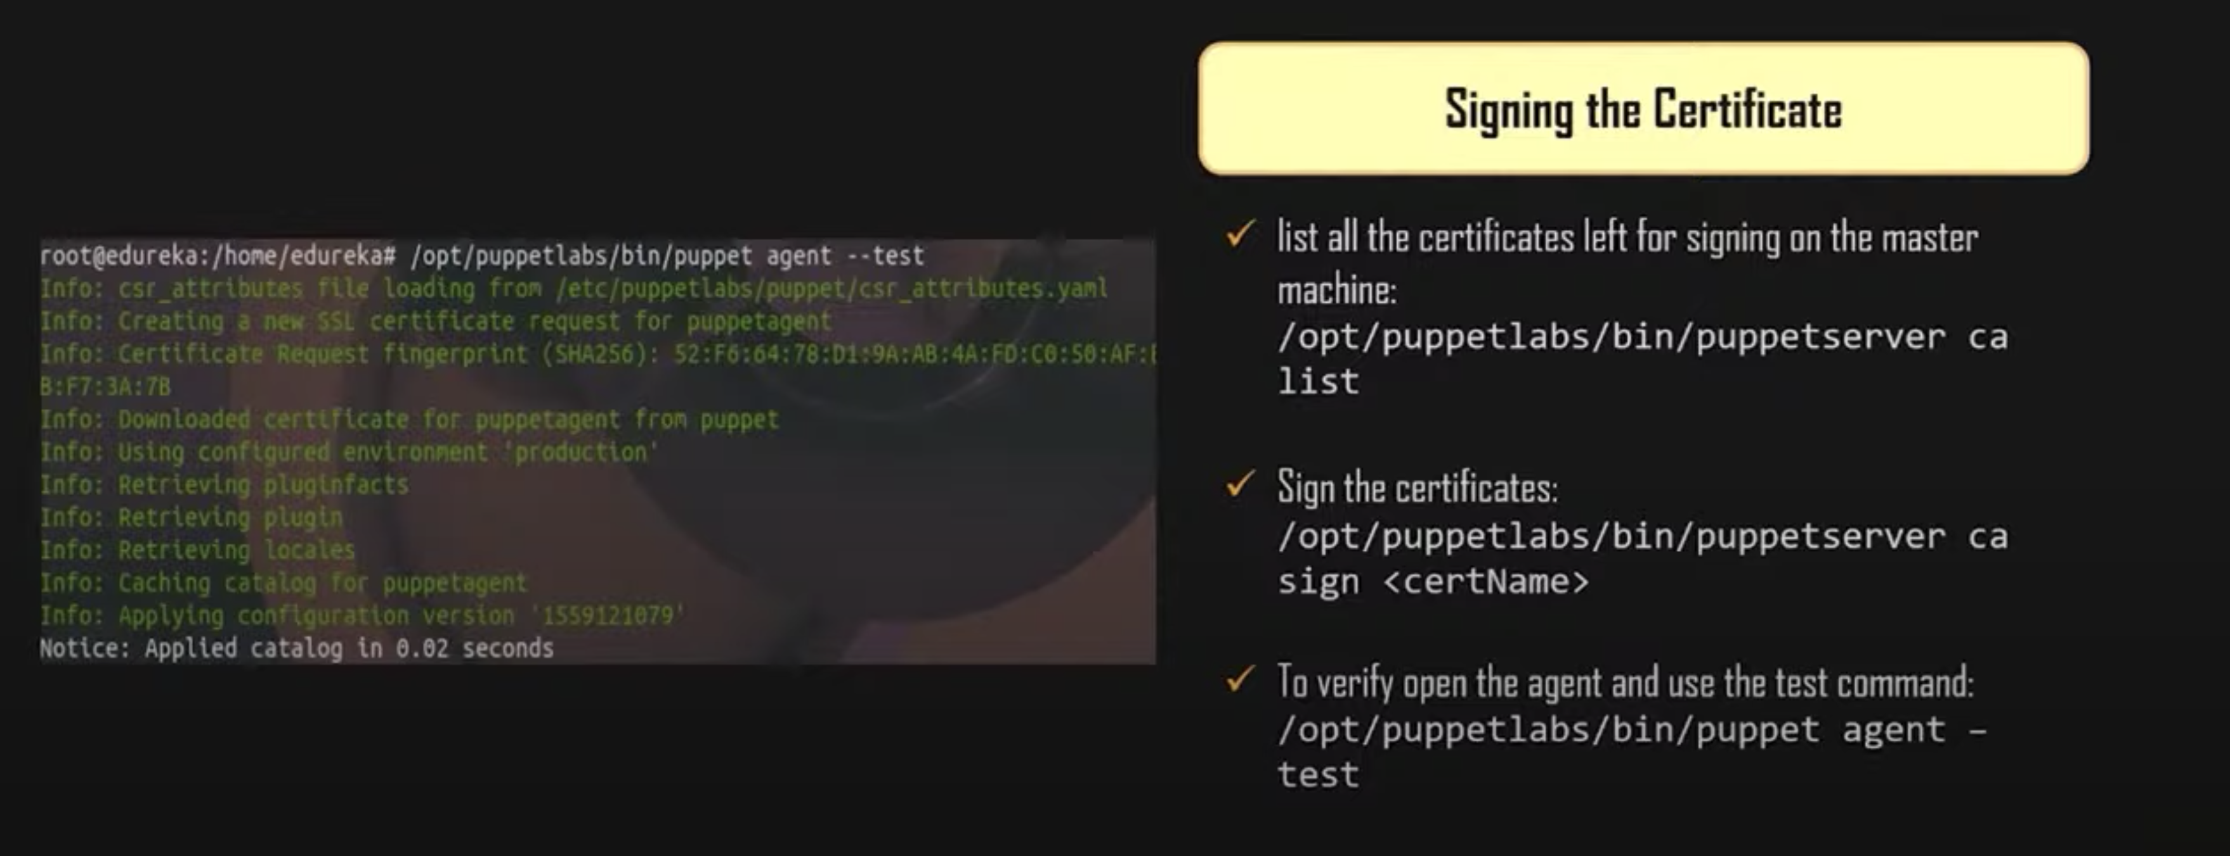

To sign the certificate we can give certname or to sign all certificates we can use -all

We can open agent run test command

**CONTINER MANAGEMANT WITH ANSIBLE:**

What is ansible?

Development + operations:

Ansible is simple opensource IT engine which automates the application deployment, intra service orchestration, cloud provisioning and many other IT tools. Not only this but ansible is also very easy to deploy because it doesn’t use any agent or custom security infrastructures.

Ansible uses playbook to describe automation jobs and playbooks uses very simple language i.e YAML.

What is YAML?

Yaml is a human readable data serialization language and is commonly used for configuration files. But it can be also used for many applications where data is also stored. This means it is very easy for the humans to understand,read and write. So the advantage of YAML file is that even the IT infrastructure support guys can read and understand the playbook and debug if needed.   
  
So its basically a really simple language makes it really simple for users to read,write and understand.

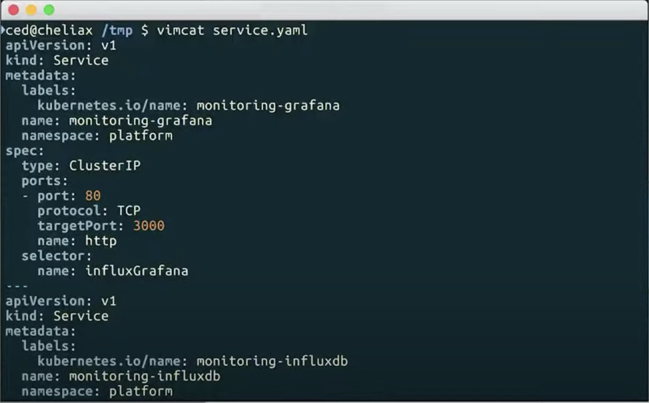

Ansible is designed for the multi thread deployments, Ansible doesn’t manage 1 system at a time, it models the IT infrastructure by describing all of the systems which are interrelated. Ansible is completely agent less which means that ansible works by connecting your nodes through SSH bydefault but if you want any other method for connection like kerberos, Ansible also gives you that option.   
  
So after connecting your Nodes, ansible pushes some programs called as ansible modules and ansible runs that modules on your nodes and removes them when they are finished. So it also manages your inventory in simple text files, those are basically host files which you can see on the screen.

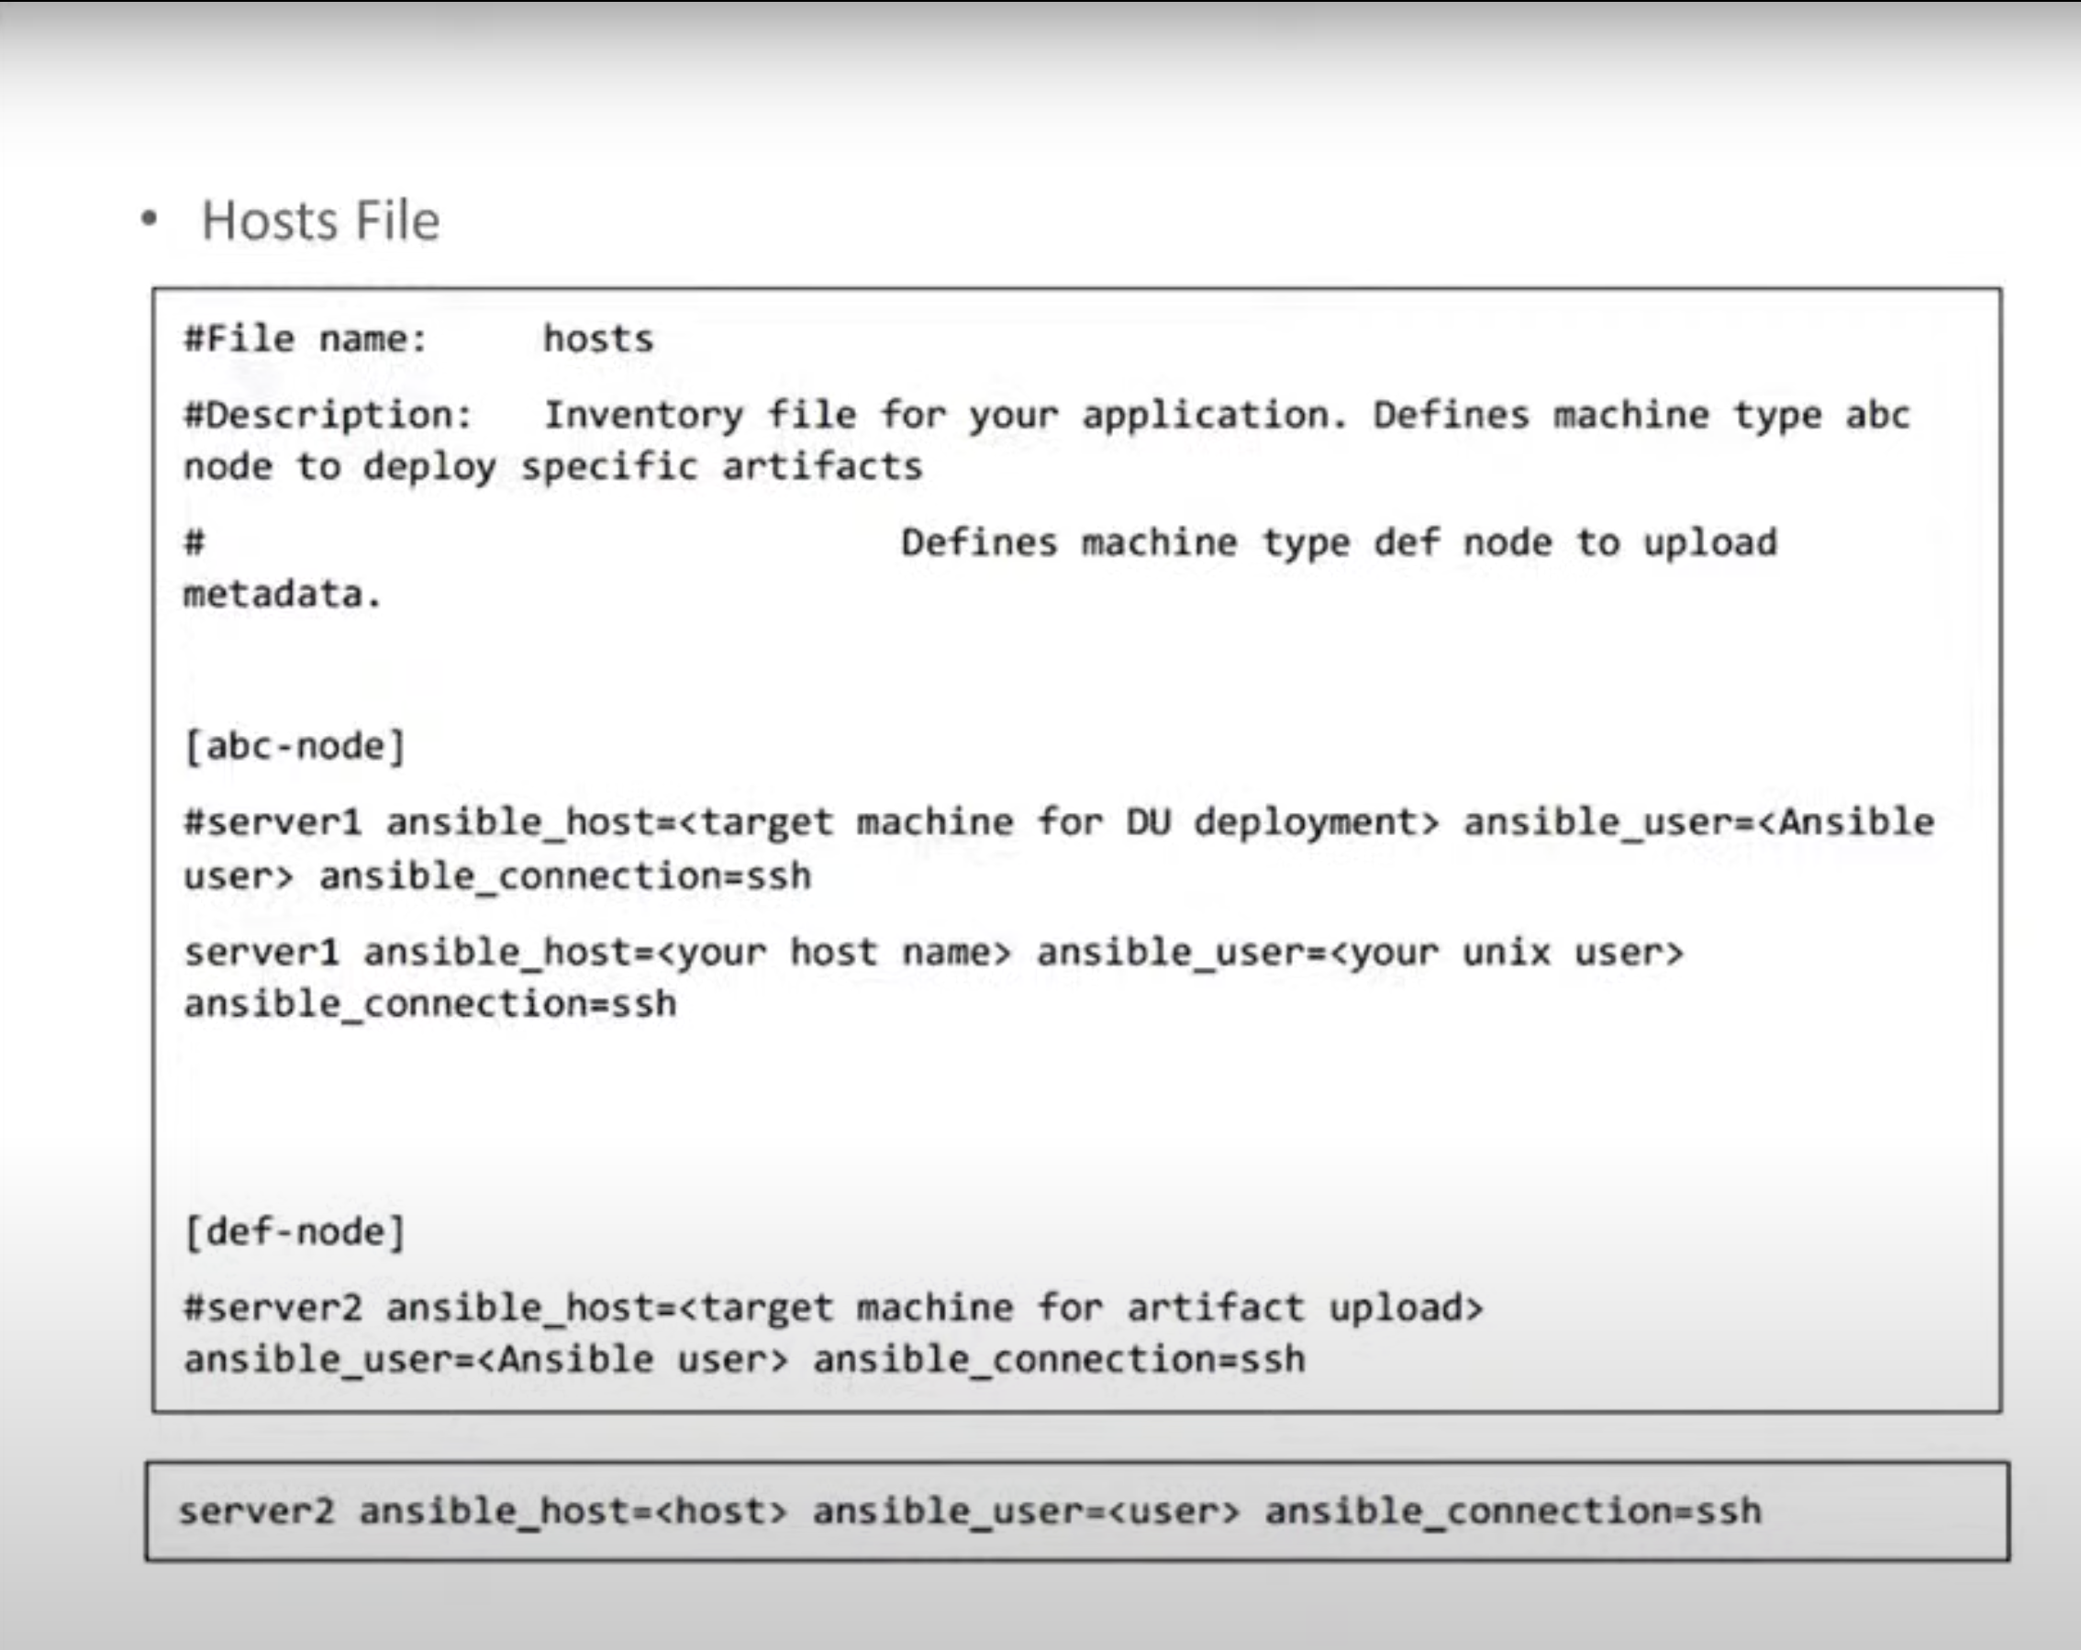

Here ansible uses the hosts file where one can group the hosts and control the actions on a specified group in the playbooks.

**HOW ANSIBLE WORKS:**

So Basically, Ansible works by connecting your nodes and pushing out small programs called as ansible modules to them. So Ansible when executes these modules over SSH by default and then removes them when finished.

So your library of modules can reside on any 1 machine and there are nodes servers daemons and dB is required.

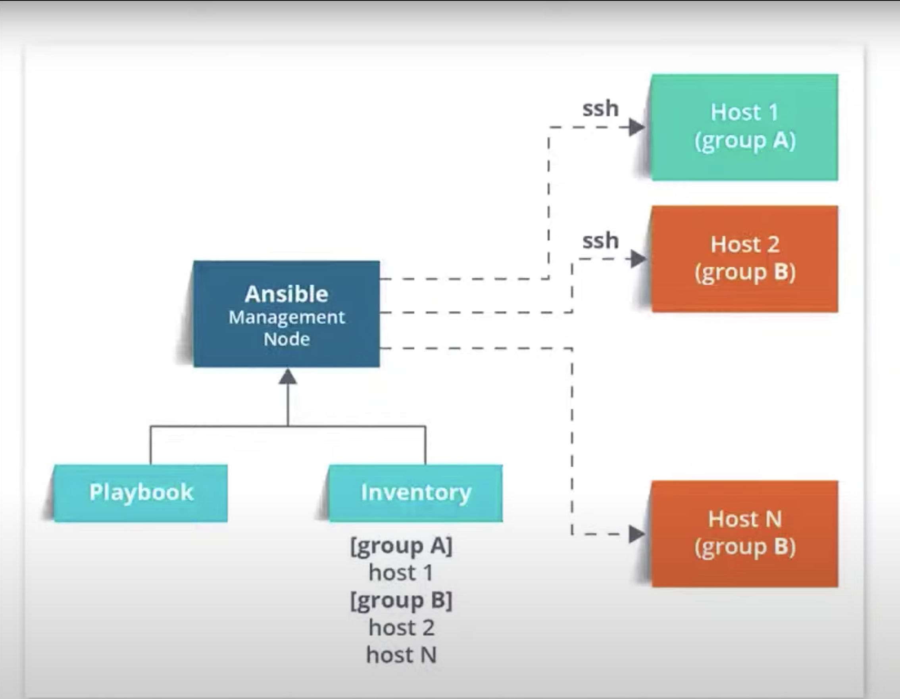

So, the management Node that you can see on the screen that is controlling Node which controls the entire execution of the playbook. It’s the Node from which you’re running the installation and the inventory file provides the list of the host where the ansible module needs to be run and the management node does a ssh connection and then it executes the small module on the host machine and installs the product.

So, the beauty of ansible is that it removes the modules once those are installed so that it effectively connects to the host machines and then it executes those instructions and if it is successfully installed then it removes the code which is already copied on the host machine and that was which got executed.

That’s how ansible works.

Features Of Ansible:

1. Agentless - by agentless I mean there is no kind of software or any kind of agent managing your node unlike puppet or chef where you need to install a puppet agent or chef client on your node machine. But for ansible you just must install ansible in your control machine and then you’re good to go.
2. Python – It is built on top of python, and this helps to provide a lot of functionalities of python.
3. SSH – Ansible used SSH for secure connections. SSH is a very simple pswdless n/w authentication protocol which is very secure. Our responsibility is to Just generate a public key in your machine and copy the same key on to your node machines.
4. PUSH – Ansible is also a PUSH based architecture for sending configurations. So, in the case of Ansible where you want to make any kind of configuration changes on your nodes, all you must do is you just have to write down that configuration and you just must push them all at once in your nodes. If you talk in simple terms, what it does is that it gives you full control on whenever you want to make changes on your nodes and makes it very easy and fast to setup and needs very minimal requirement.

**Diff b/w PUSH based and PULL based architecture:**

Tools like puppet and chef are Pull based configuration management tools, whereas Ansible is Push based configuration management tool.

In the case of Puppet and chef their agent presents the agent s/w that puppet has and is basically called as the puppet agent and in case of chef it is known as Chef client.

What this agent does is that it keeps on pulling the central server periodically for any kind of configuration information and whatever it finds it pulls those changes and then gets them effected on your node machines whereas in the case of ansible there are no agents present Wherever you want to make any changes you can make those changes directly and push those configurations directly whenever you want to as you have got full control over it.

Not only this but also in a push-based configurations management system.

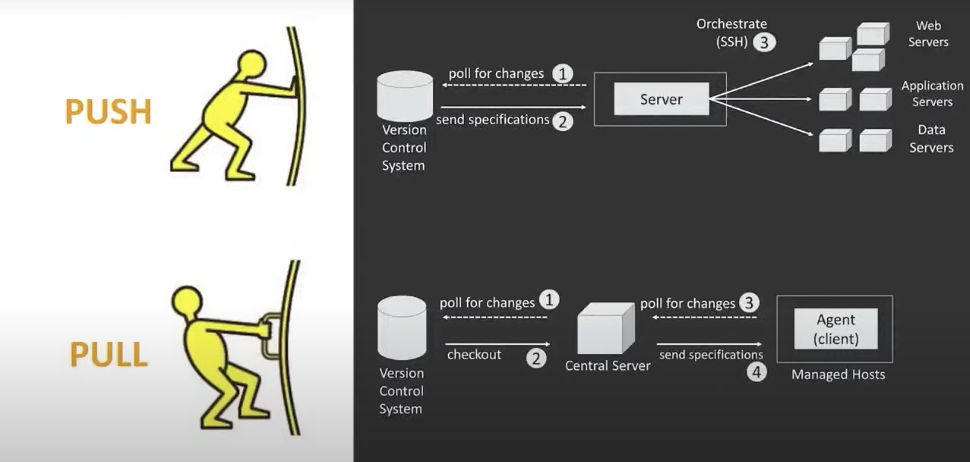

As you can see on the screen there is a version control system (VCS) which manages all the changes in the code base and then we have a server which will have Ansible or any other configurations management tool system installed there and we have a bunch of nodes which are collection of web servers, application servers and data servers and all these are connected to the main server via SSH.

What happens here is that this main server constantly pulls the VCS for any changes in the code base which means it constantly keeps on checking the status of VCS at regular intervals of time. And whenever there are any kind of changes, those specifications are sent to the main server and then the server decides on how to take those configuration changes according to the changes in the code base.   
  
In the situation where you want to write all these new configurations, you can directly push them all at once on to your node machines. So, you have got full control here and whenever you want to make any changes you can make the required changes.  
  
  
Coming to Pull based configuration the relation b/w the VCS and central server is the same. It constantly pulls for the changes that the VCS for any change in the code base and whenever there are changes it pulls those changes. But the main diff both the architectures is that from a push-based configurations management tool is that it has got an agent present and then this agent/client is the s/w that manages all the nodes. What this agent does is that it constantly pulls the central server for any configuration changes. This means it keeps on checking the central server for any changes in the configuration that needs to be made and wherever it finds any kind of configuration changes it pulls those changes and then only it gets affected on to the node machines.

So, at this point you must wait for that agent to pull those changes and only then the configuration changes will get effected on to your nodes.

The basic point is you have to be little bit dependent on the agent here and the improvement tools.

So Ansible is simple. It’s very easy to learn as it gives us the simplicity of push-based system. But there is a disadvantage with this system that’s because you cannot achieve full automation with push-based system because its not usually possible to boot a server and have it configured without some sort of client/server protocol and also it gives you a lack of scalability as well as when you dealing with hundreds of servers a push based system will starts showing its limits unless you make use of threading a multi-processing.

How to Install :

Before we go with the steps to install Ansible, there are two types of machines when we talk about deployment. Those are the control machines and the remote machines. So the control machines are the machines from where we can manage the other machines and the remote machines are those machines which are handled/controlled by control machine. There can be multiple remote machines handled by a single control machine. So for managing remote machines we have to install the ansible on the control machine.

Steps to install Ansible:

sudo apt-get update

you need to install common s/w properties.

sudo apt-get install software-properties -common

next,

sudo apt-add-repository ppa:ansible/ansible

so this will basically include your ansible repository.

Next again need to update repository

sudo apt-get update

Next we need to install Ansible,

sudo apt-get install ansible

